Default setting:

1. epoch=50

2. I use the StandardScaler, rather than the MinMaxScaler as you might have seen before. The reason is that stock prices are ever-changing, and there are no true min or max values. It doesn’t make sense to use the MinMaxScaler, although this choice probably won’t lead to disastrous results at the end of the day

3. Since stock prices prediction is essentially a regression problem, the RMSE (Root Mean Squared Error) and MAPE (Mean Absolute Percentage Error %) will be our current model evaluation metrics. Both are useful measures of forecast accuracy. RMSE tells us how far off the predictions are on average, while MAPE tells us what percentage of the actual values these deviations represent. The lower these values are, the better, as it means the predictions are more accurate.

(1) hidden layer = 6, barch size =64, dropout =0.5, unites = 260. Using 14 days stock price to predict 14 days stock prices.

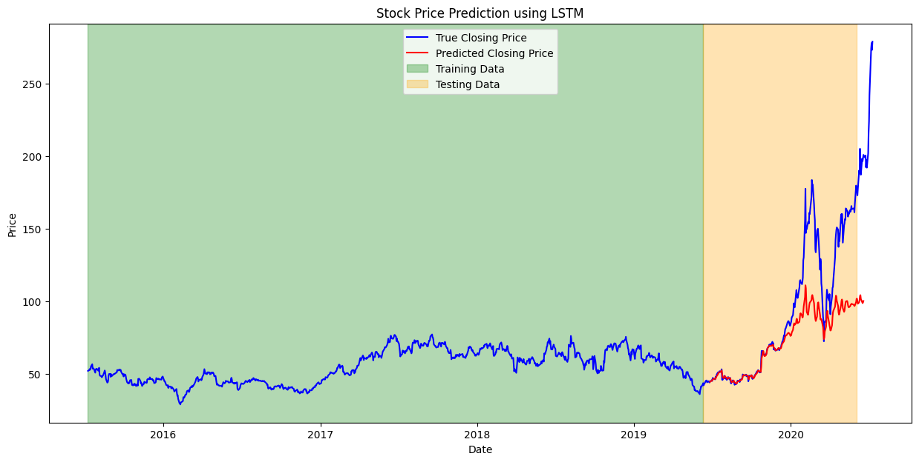

RMSE: 37.437471714398974

MAPE: 16.34891607539829%

(2) hidden layer = 2, barch size =64, dropout =0.5, unites = 260. Using 14 days stock price to predict 14 days stock prices.

RMSE: 16.68751142821044

MAPE: 8.084759722705286%

(3) hidden layer = 2, barch size =32, dropout =0.5, unites = 260. Using 14 days stock price to predict 14 days stock prices.

RMSE: 12.83102782759476

MAPE: 6.4993238644715206%

(4) hidden layer = 2, barch size =32, dropout =0.2, unites = 260. Using 14 days stock price to predict 14 days stock prices.

RMSE: 20.09517629528101

MAPE: 9.188613627371375%

(4) hidden layer = 2, barch size =32, dropout =0.5, unites = 50. Using 14 days stock price to predict 14 days stock prices.

RMSE: 49.86460826472332

MAPE: 23.22692155135534%

based on these pics, we can find:

(1)when hidden layer= 2, the model performance is better than hidden layer=6.

(2) models with a batch size of 64 seem to perform worse for long-term predictions compared to those with a batch size of 32.

(3) A large dropout is better than small dropout.

(4) Larger unit performance is better than small units, maybe because large units can grasp more features.

Now , we use the best parameters which based on the 14 days, to predict 7 days and 1 days.

(1) hidden layer = 2, barch size =32, dropout =0.5, unites = 260. Using 7 days stock price to predict 7 days stock prices.

RMSE: 13.946047308416064

MAPE: 6.550110162495964%

(2)hidden layer = 2, barch size =32, dropout =0.5, unites = 260. Using 14 days stock price to predict 14 days stock prices.

RMSE: 12.83102782759476

MAPE: 6.4993238644715206%

(2)hidden layer = 2, batch size =32, dropout =0.5, unites = 260. Using 1 days stock price to predict 1 days stock prices.

RMSE: 19.522045746357907

MAPE: 7.045470276667025%

RMSE is a measure that calculates the magnitude of error between the predicted values from a model and the actual values. An RMSE of 19.52, in this context, means that on average, the model's predictions of the stock price deviate from the actual stock price by about 19.52 units.

MAPE, on the other hand, is the average percentage error, which indicates how much the model's predictions, on average, deviate from the actual values as a percentage. A MAPE of 7.04% indicates that, on average, the model's predictions deviate from the actual stock price by 7.04%.

So, from the results above, we can find Using 14 days stock price to predict 14 days stock prices, the model performance is better than use 1/7 days stock price to predict 1/7 days stock prices